Jane's comments and tips
Note my 2 examples.
- I used a lot of low-volume and it was useful as I played around before cutting.

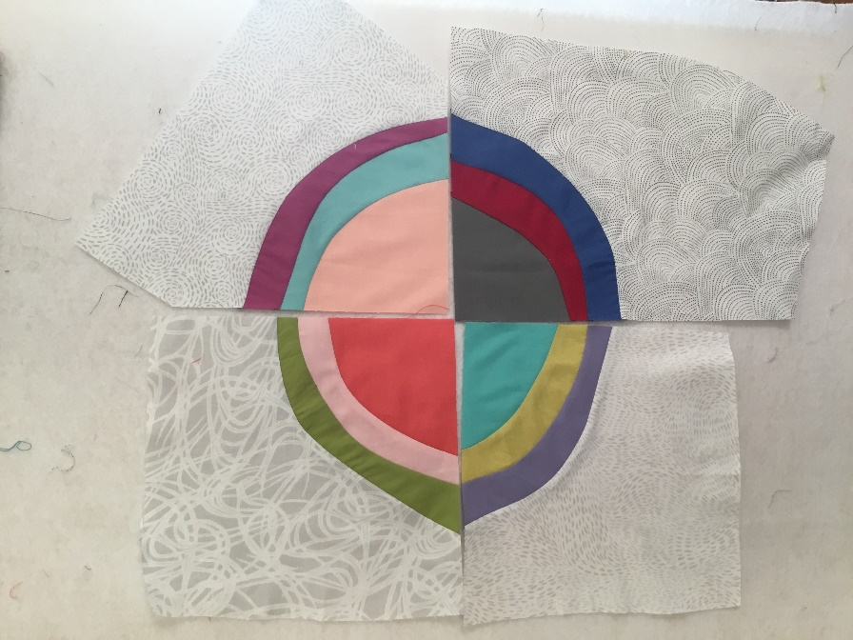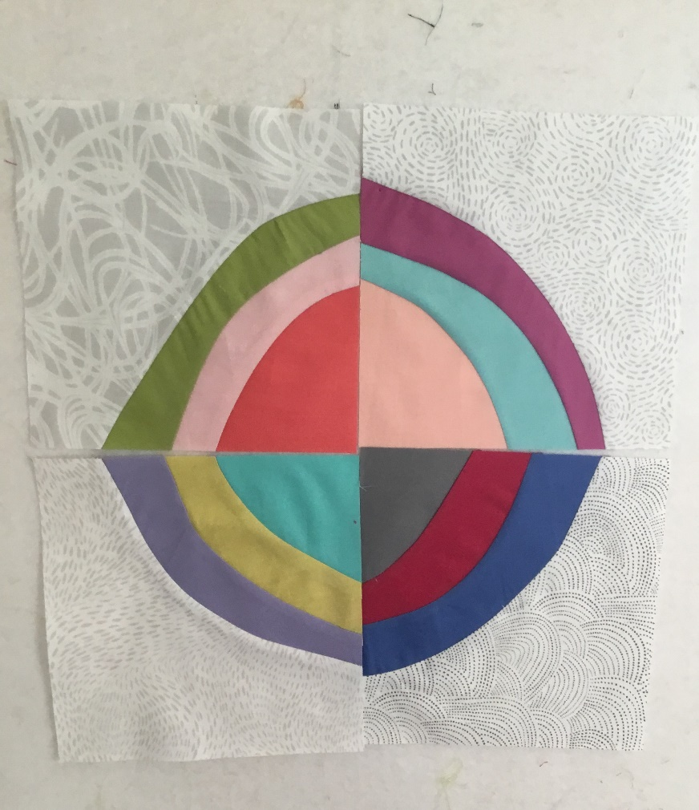

- Second block...you can see my “mistake” here...In order to have 1” of fabric in top left I had to allow the bottom radius to be 3”.
Before cutting to 6.5”...
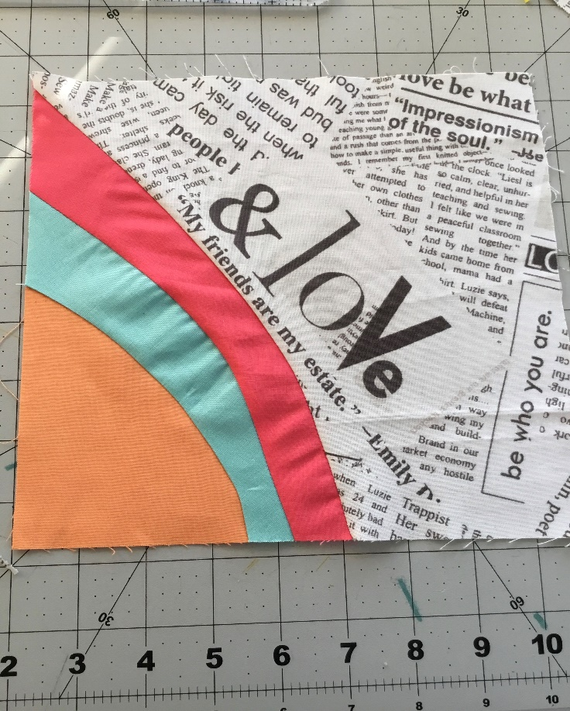

After cutting to 6.5"…
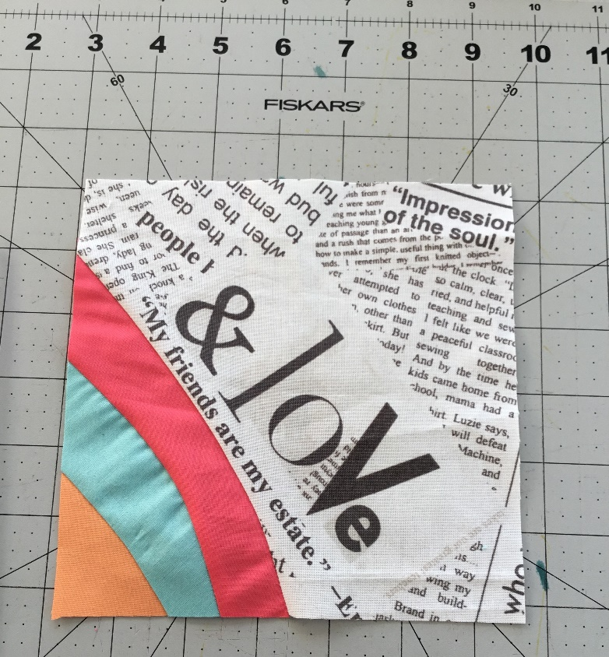
But I think, in the end, it all works. That’s what wonky is, right, and these are wonky times...

Final blocks…
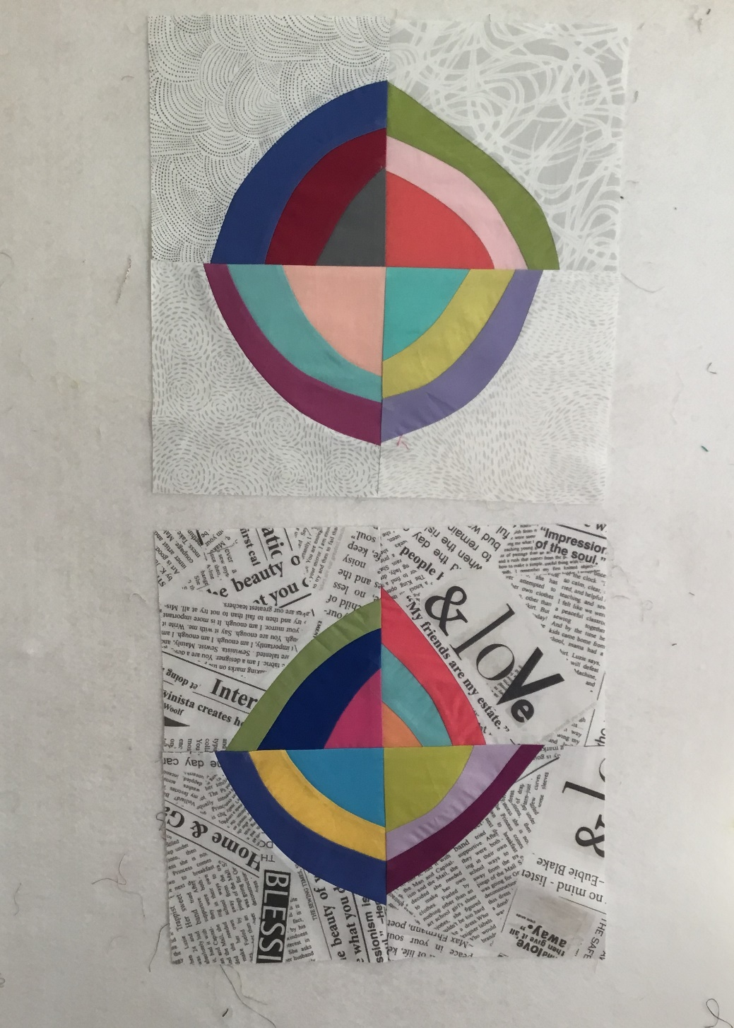

PS Low volume fabrics can be described as basically subtle white, cream, neutral or pale coloured print fabrics often with a delicate self-coloured pattern or subtle design and they are selected to offset the much brighter palette of colours available in many fabric lines. Think of pale floral designs, faint spots or those white fabrics with text and these would be described as low volume – your eye sees them as soft colours even though they are not entirely plain. Low volume fabrics won’t ‘fight’ with more colourful fabrics and will let those bright prints shine!

